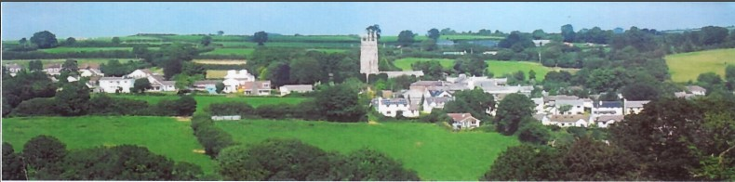

26th February 2025

Dear Councillor,

You are summoned to attend a meeting of North Hill Parish Council on Monday 3rd March 2025 at 7.30pm in the Village Hall.

Please find attached the agenda for our meeting. We ask that if any member of the public has issues, they would like to raise that they contact the clerk prior to the meeting so that we can best manage them.

Please remember that the time allotted for Matters of Community Concern is not a forum to discuss what has taken place during this meeting and that any matter raised here would likely be added to the NEXT meeting agenda for discussion.

Yours faithfully,

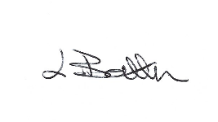

Lena Batten, Clerk to the Council

Members of the public are welcome to attend the meeting. However, we would like those attending to register prior to the meeting by emailing the Parish Clerk. Email: [northhillparishcouncil@btinternet.com](mailto:northhillparishcouncil@btinternet.com)

**AGENDA**

1. TO RECEIVE APOLOGIES:
2. CODE OF CONDUCT : a) TO RECEIVE DECLARATIONS b) TO GRANT DISPENSATIONS:

3. PUBLIC COMMENTS ON ITEMS ON THE AGENDA ONLY:

4. TO RECEIVE AND APPROVE THE MINUTES OF THE 3rd FEBRUARY 2025 FULL COUNCIL MEETING:

5. ANY MATTERS ARISING FROM PAST MINUTES NOT ON THE CURRENT AGENDA:

6. TO CONSIDER PLANNING APPLICATIONS RECEIVED FROM CORNWALL COUNCIL BY DATE OF THIS MEETING:

6.1 To note for information only - PA25/00117 – Hirundo, Lime Tree Way, Coads Green, PL15 7LW - Proposal Exception notice for works to a lime tree – closed, advice given.

6.2 To note for information only - PA25/00526 - S52/S106 and discharge of condition apps - The Bull Pen, Tolcarne Road, North Hill, Launceston, PL15 7PE - Proposal Submission of details to discharge condition 3 in relation of Decision notice PA21/06576 dated 27.01.2022.

6.3 To note for information only – PA25/00884 – Land adj Landreyne Barn, Penhole Road, Coads Green – Reserved matters application for appearance, landscaping, layout and scale for the construction of one dwelling – site meeting took place on the 15th February 2025 – North Hill Parish Council had no objection to the application and felt that the plans were sensitive to the surroundings.

6.4 PA25/00982 – The Shippen, Lower Newtown Farm, Coad Green – Construction of new garage within the existing parking area, Installation of new PV solar panels.

7. ANY APPLICATIONS RECEIVED BEFORE THE DATE OF THIS MEETING:

8. TO REVIEW CORRESPONDENCE AND TO AGREED RESPONSES REQUIRED:

8.1 To agree / resolve the co-option of one member of the public present at the meeting.

8.2 To receive further information obtained by Cllr R. Hudson in relation to Voice over telecommunication resilience and emergency management planning.

8.3 To agree / resolve to share member induction packs by email at the Annual Parish Meeting.

8.4 To resolve full Council make themselves aware of the difference between Permitted Development and Permission in Principle when commenting on planning applications.

8.5 To consider / resolve any response to the request from EP&E local plan for and suitability of potential sites as requested under their “call for sites” with a submission deadline of 19th March.

8.6 To consider / resolve the offer of a free cybercrime awareness presentation from Devon and Cornwall Police.

8.7 To consider / resolve any response to Redruth Town Council regarding a fairer way to distribute the proceeds for second home council tax premiums.

8.8 To consider whether to make an application to the Community Capacity Fund for 2025-26 by December 2025 for the purchase of new gates for the cemetery.

8.9 To accept feedback from the clerk regarding potential purchase of a tank printer.

8.10 To agree / resolve to accept the ROSPA annual inspection at £80.00 plus VAT if accepted by the 11th March otherwise additional costs are applied. To agree whether to “opt in” to automatic annual checks.

8.11 To accept / resolve the purchase of a bench seat in memory of Councillor B. Ruby following quotes received.

8.12 To agree as requested by Parnalls Solicitors, from Councillors and clerk a full descript as to use, occupation and activities carried out on the Car park land. This will need to include dates.

9. TO REVIEW DETAILS FOR NORTH HILL PARISH COUNCIL CEMETERY:

Currently no details to review, Cemetery Committee will arrange a further meeting following the Annual Parish Meeting to be held on the 15th May 2025.

10. APPROVAL OF THE LIST OF PAYMENTS / RECEIPTS FOR FEBRUARY 2025 & TO RECEIVE FEBRUARY 2025 BANK STATEMENT:

10.1 AUTHORISATION OF EXPENSES INCLUDING SALARY:

i) £18.00 (PAYE G. Pollard payroll February, dd)

ii) £759.20 (Lena Batten, February Salary / tax)

iii) £43.64 (room rent)

iv) £194.39 (TEEC website)

v) £128.47 (Kompan play inspection)

vi) £48.00 (bleed control kit)

vii) £25.00 (purchase of M&S Voucher Lena Batten for facilitation of defib)

10.2 RECEIPTS: None.

10..3 To receive bank statement:

Bank Statement as of 21th February 2025 £14,717.53

10.4 To agree / resolve the minimum amount required of £500.00 to be sent to Unity Bank to open current account and proceed with application.

11. TO REVIEW MONTHLY BUDGET RECONCILIATIONS:

11.1 Budget Sheet Attached.

12. TO REVIEW MONTHLY RAG: (Red, Amber, Green)

12.1 RAG Sheet attached.

13. REPORT FROM CORNWALL COUNCIL WARD MEMBER COUNCILLOR PARSONS:

14. ITEMS FOR INCLUSION AT THE NEXT MEETING:

15. DATE & TIME OF NEXT MEETING:

16. CLOSE OF BUSINESS: